Driving examiner: candidate pack

(Fixed-term contract, up to 24 months with potential for permanency)
Salary: £26,126 | Location: Various, see application for details

DVSA – who we are
Great Britain’s roads are among the safest in the world.
At the Driver and Vehicle Standards Agency (DVSA), we play a vital role helping millions of people stay safe on our roads – our vision is safer drivers, safer vehicles, and safer journeys for all.

What we do
We help millions of people every year. We make sure learners are safe to drive, by approving driving instructors and conducting driving and theory tests. We help people keep their vehicle safe to drive by approving MOT testers and inspecting vehicles. And our teams help protect the public from unsafe vehicles and drivers through roadside enforcement activities.
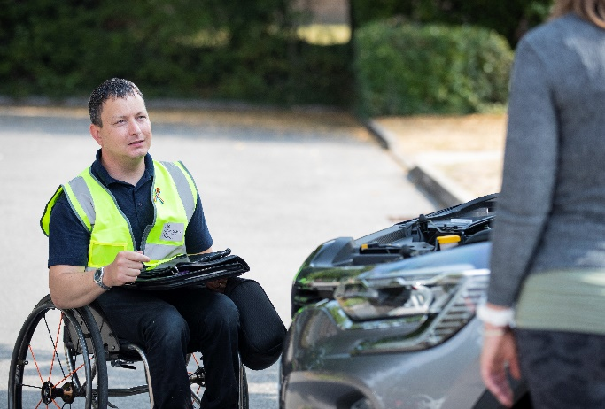 | 1.9 million  driving tests each year
2 million  theory tests each year | 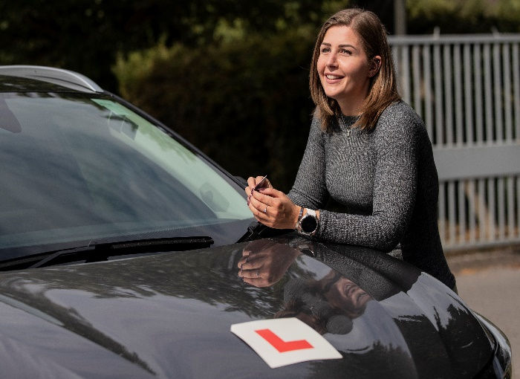

Why join DVSA?
As a driving examiner, you’ll be on the frontline of road safety in Great Britain.
Every day, you’ll be involved in a crucial life moment for thousands of nervous drivers as they take their driving test.
Your knowledge, driving skills and judgement will determine if they are ready and safe to take to the road alone.
You’ll get to meet people from all backgrounds, while being an important part of a tight-knit, diverse team, all focussed on helping people start a lifetime of safe driving.
You’ll get to use your people skills, and develop great customer service, as you meet and greet candidates and instructors and reassure nervous learners.
Whether you’re looking for a new challenge, considering a career change or have a keen interest in road safety, we’ll support you with the training you need to become a driving examiner and truly make a difference to road safety, and thousands of lives, in Great Britain.
This is a fantastic opportunity to join our team and make a real difference to road safety.

Diversity and equality
The Civil Service is committed to becoming the most inclusive employer in the UK.
At DVSA, you’ll be part of an innovative organisation that invests in all our people, ensuring we have the diverse skills to deliver transport that moves Britain ahead now and into the future.
We welcome applications from every part of the community. We’re particularly interested to hear from Black, Asian, and Ethnic people, women, disabled people, and those who identify as LGBT+. We believe everyone is involved in making DVSA an inclusive and great place to work.
For more information on Civil Service Recruitment Principles, see the Civil Service Commission website.

Working at DVSA
We offer a wide range of employee benefits, such as:
Flexible working, including part-time working and job share options

Generous Annual Leave, public holidays, and paid privilege entitlement to mark the Queen’s Birthday.
Access to apprenticeships from L2 - L7 and study leave

Fast, modern IT kit enabling seamless collaboration working

Childcare schemes and generous parental and carer schemes

Development Opportunities

Cycle to work scheme

Plus, lots more benefits, discounts, and schemes. See more at DVSA Careers

About the Job
Driving examiners play a vital frontline role, using their knowledge to judge whether customers pass the driving test.
This is an exciting opportunity to join the team and make a real difference to road safety in Great Britain
You’ll be welcoming candidates and instructors to test centres, working within a close, diverse team of professionals, all focussed on helping people start a lifetime of safe driving.
- You will work within a cluster. Please note, a one-off incentive payment of £1,500 is payable at certain clusters – please refer to list attached to the bottom of the advert.
- Carry out car driving tests building rapport with the customer, be professional ensuring you tailor your approach to consider any needs customers may have.
- You’ll supervise the test and assess the level of driving displayed by the customer, ensuring they reach the required standard and accurately complete test reports.
- Support the Local Driving Test Manager when you’re not carrying out tests and work with your colleagues to maintain an effective working environment.
- As a full-time driving examiner, you will test 5 out of 7 days working a 37-hour week. We offer a variety of flexible work patterns including part-time and rotational weekend working. You will have the opportunity to discuss your preferred working pattern upon successful offer and before starting the training course. (Please note the 5-week training course can only be completed on a full-time basis)
Who are we looking for?
You’ll be an experienced driver with excellent judgement. You will be committed to safe driving and improving road safety with the ability to reassure and support leaner drivers. You will possess excellent communication and customer service skills to deliver high-quality service in a fast-paced environment while making timely, justified and sometimes difficult decisions.
You’ll have a calm persona, be able to thrive under pressure, multi-task, and can put learner drivers at ease during a nerve-wracking experience.

Essential skills and Experience
- You must be aged 23 or over (a requirement of the 3rd EU Driving Licence Directive - Directive 006/126)
- You must have held a UK or EU driving licence continuously for the last 3 years.
- You must have no more than 3 penalty points on your licence
- Experience of delivering high-quality customer service
- Strong ability to work collaboratively to achieve personal and group objectives.
- Effective oral and written communication skills
- You will need to be a competent driver

Success Profiles

We assess applicants using specified Success Profiles. This assesses a range of elements using a variety of methods. This provides the best possible chance of finding the right person for the job and improve diversity and inclusion.
You will be expected to demonstrate the following Civil Service Behaviours
- Managing a Quality Service

- Working Together
- Making Effective Decisions

- Communicating and Influencing

The Application Process
There are several stages to the application and assessment process.

Application
You should submit your application via the Civil Service Jobs website - www.civilservicejobs.service.gov.uk
You’ll need to complete an online judgement test This is to test your skills as a Civil Servant and measure your ability to demonstrate judgement and decision-making regarding specific Civil Service Behaviours, which have been selected as important for success in your chosen job. (See advert). This means questions are more rounded and not solely linked to the role of a Driving Examiner. Please see below links for more guidance on this.
- Example of Civil Service Judgement Test
- Civil Service Judgement Test Video

Interview and assessment
If you pass shortlisting stage, you will be invited to undertake a pre-recorded online interview.
You will have the opportunity to respond to questions that have been selected for this role - the best part - you can take this interview anywhere and at a time that is convenient for you within the deadline.
The interview offers you the following benefits:
- The chance to bring your skills and attributes alive
- Really demonstrate why you're ideal for the job
- Demonstrate your communication skills in 'real-time'

We encourage you to complete this interview as soon as possible before the deadline so we can help you if you require any technical support.

Driving assessment
Successful interview candidates will be invited to a driving assessment (undertaken in a manual car, provided by DVSA).
- You will be required to drive on various types of roads and in different traffic conditions. This will include a section of independent driving.
- You’ll be asked to give a short talk-through of your observations, including how you prioritise risks and plan your responses accordingly. Safety and technique will be assessed, while being mindful of eco-safe driving techniques.
Full requirements detailing these 12 proficiencies will be sent to all shortlisted candidates who are invited for a driving assessment. To find out more visit DVSA Driving Examiner.

Fixed Term Contracts
We intend to employ extra driving examiners to help meet this demand over a fixed period, which means your contract will be up to 24 months in duration. This is a temporary position, and the type of contract you will be offered will depend on your current contract status.

External candidates
- If you are not currently employed by the Civil Service, you’ll be issued with a fixed term contract. Towards the end of the fixed term period, we will reassess our business needs and requirements and if appropriate, you may be offered an ongoing contract.

Across Government (OGD)
- If you are already employed by another government department, either on a permanent or fixed term basis, you will require agreement from your manager and department to apply, then be loaned to the DVSA for the duration of the fixed term contract.
- At the end of your loan, you will return to your home department. If this is not possible due to organisational changes/business reasons, you will be treated in accordance with any applicable redeployment processes or loan guidance.

Find out more about working with us
If you want to learn more about us, our culture, and what it's like working with us, please see below.
To apply for this role, and to see other vacancies at DVSA, visit Civil Service Jobs: www.civilservicejobs.service.gov.uk
To find out more information about our virtual events and open days, please visit our Driving Examiner page
Driving Examiner Information
Get more info about DVSA, our work and service, at GOV.UK: www.gov.uk/dvsa
Read Despatch, our blog for driver and rider trainers: https://despatch.blog.gov.uk/
Sign up for DVSA Directs on driver and rider training and updates to the Highway Code: www.gov.uk/guidance/dvsa-email-alert

You can also follow us on social media:
Twitter – @dvsagovuk Facebook – DVSAgovuk LinkedIn – Driver and Vehicle Standards Agency

