Driving examiner: candidate pack
  - (Fixed-term contract, up to 24 months with potential for permanency)
Salary: £26,126 | Location: Various, see application for details

DVSA - who we are
Great Britain’s roads are among the safest in the world.
At the Driver and Vehicle Standards Agency (DVSA), we play a vital role helping millions of people stay safe on our roads – our vision is safer drivers, safer vehicles and safer journeys for all.

What we do
We help millions of people every year. We make sure learners are safe to drive, by approving driving instructors and conducting driving and theory tests. We help people keep their vehicle safe to drive by approving MOT testers and inspecting vehicles. And our teams help protect the public from unsafe vehicles and drivers through roadside enforcement activities.
1.9 million  driving tests each year | 38.5 million  MOT certificates issued each year
2 million  theory tests each year | 31,958  defective vehicles discovered each year

Why join DVSA?
As a driving examiner, you’ll be on the frontline of road safety in Great Britain.
Rich Hennessy
Director of Operations (South)
Peter Hearn
Director of Operations (North)

Every day, you’ll be involved in a crucial life moment for thousands of nervous drivers as they take their driving test.
Your knowledge, driving skills and judgement will determine if they are ready and safe to take to the road alone.
Working from local driving test centres, you’ll get to meet people from all backgrounds, while being an important part of a tight-knit, diverse team of professionals, all focussed on helping people start a lifetime of safe driving.
You’ll get to use your people skills, and develop great customer service, as you meet and greet candidates and instructors and reassure nervous learners.
You’ll get to see the smiles and celebrations when you confirm a pass. But you’ll also need a clear, calm manner to explain your decisions and deliver the disappointing news of a failed test.
Whether you’re looking for a new challenge, considering a career change or have a keen interest in road safety, we’ll support you with the training you need to become a driving examiner and truly make a difference to road safety, and thousands of lives, in Great Britain.
This is a fantastic opportunity to join our team and make a real difference to road safety.

Our staff
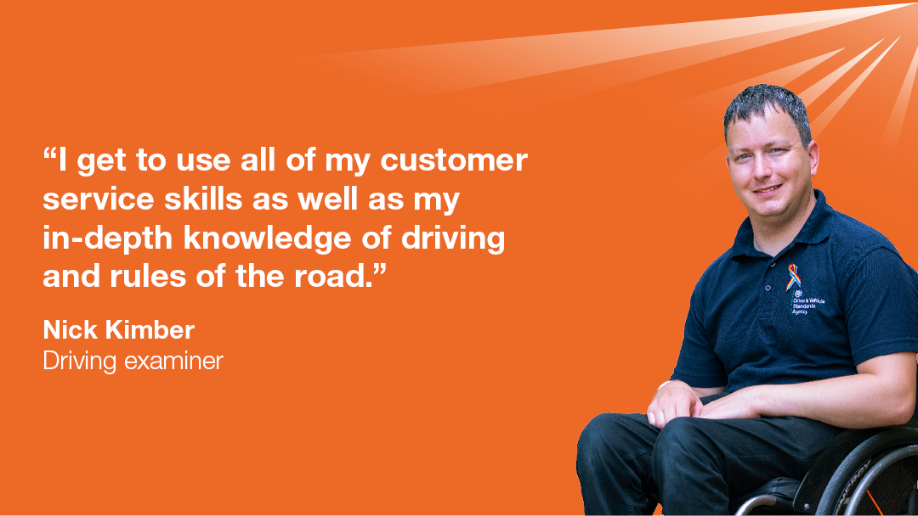
Nick is a driving examiner in the Operations South team
I have a keen interest in road safety and joined DVSA in 2015, after spending 11 years as a driving instructor.
I get to use my customer service skills, as well as my in-depth knowledge of driving and the rules of the road, and I’m part of the team that make sures the test centre runs smoothly.
“DVSA is a great place to work. I get to meet people from all walks of life and become part of their learning to drive journey.”
Career progression is also a big plus – I’ve progressed to become a mentor, so I help bring new driving examiners into the agency and help with their training. If you want to progress into other areas of the civil service, this is an option too.
I feel valued and trusted in my job and feel DVSA promotes a well-rounded working culture in which everyone is respected. I would highly recommend DVSA as a place to work.
You can read more about working at DVSA on our Careers site.

Working at DVSA
We offer a wide range of employee benefits, such as:
Personal development | Rewards | Great work/life balance
Access to in-role apprenticeships up to level 7 | Employer pension contribution rate of up to 30.3% | Fast, modern IT kit and phones enabling seamless working from home and collaboration across the agency
Study leave | Tax free childcare scheme | Generous parental and carer schemes
3 paid volunteer days per year | 25 days annual leave, increasing on a sliding scale up to 30 days. Plus 8 public holidays and one further day of paid privilege entitlement to mark the Queen’s Birthday. | Flexible working, including part-time working and job share options
Individual Personal Development Plans | Special recognition awards | Free health checks including workplace adjustments
Minimum of 5 funded training days per year, plus 6-month development opportunities | Cycle to work scheme | Help and support with your home and work life, and wellbeing

Diversity and equality
The Civil Service is committed to becoming the most inclusive employer in the UK.
At DVSA, you’ll be part of an innovative organisation that invests in all our people, ensuring we have the diverse skills to deliver transport that moves Britain ahead now and into the future.
We welcome applications from every part of the community. We’re particularly interested to hear from Black, Asian, and Minority Ethnic people, women, disabled people and those who identify as LGBT+. We believe everyone is involved in making DVSA an inclusive and great place to work.
The Civil Service strives to have diversity and promotes equal opportunities for all. There is a Disability Confident Scheme (DCS) for candidates with disabilities who meet the essential criteria.
For more information on Civil Service Recruitment Principles, see the Civil Service Commission website.

Why DVSA?
Our vision is to support and develop everyone who works for us. Our passion for diversity and equality helps us create a positive working culture for all employees, and we’re friendly, welcoming, respectful and full of opportunities for professional and personal development.
As well as being a DCS employer, we are proud to be members of and champion Stonewall Diversity, Business Disability Forum, The Prince’s Responsible Business Network, ENEI and Employers for Carers.
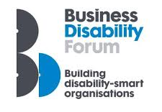

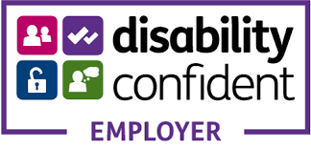

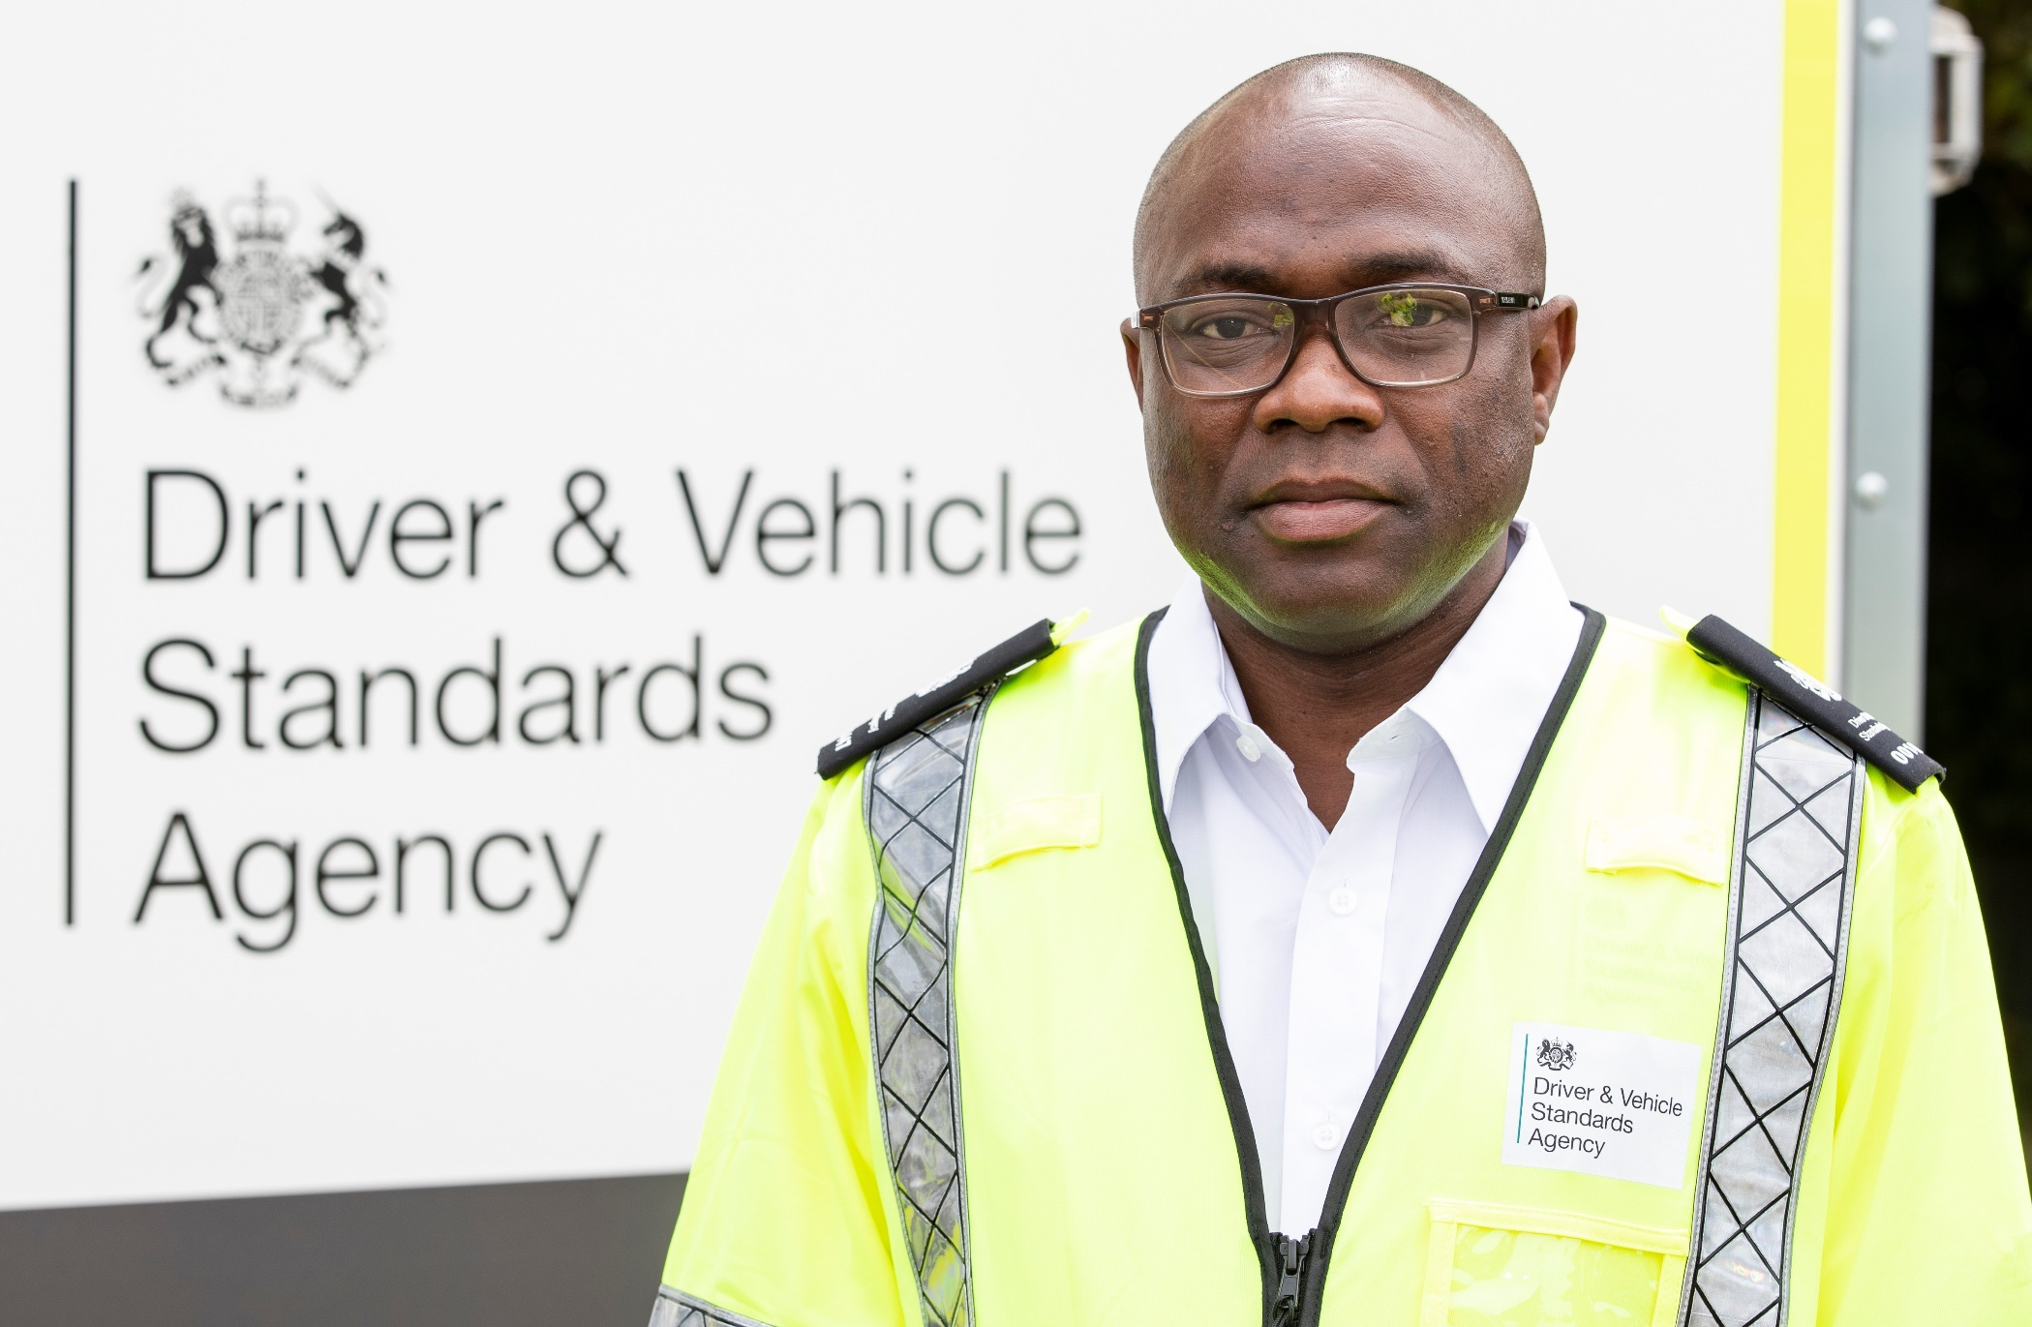

About the job

About the job
Driving examiners play a vital frontline role, using their knowledge to judge whether candidates pass the driving test.
This is an exciting opportunity to join our team and make a real difference to road safety in Great Britain
Meeting people from all backgrounds using your excellent people and customer service skills, you will experience the smiles and celebrations when you confirm a pass. However, you’ll also need a clear and calm manner to explain your decisions and deliver the disappointing news of a failed test.
You’ll be welcoming candidates and instructors to test centres, working within a tight-knit, diverse team of professionals, all focussed on helping people start a lifetime of safe driving.
As a driving examiner, you will:
- Work within a cluster, (see location attachment below) carrying out car driving tests. You will be building rapport with the test candidates, be professional ensuring you tailor your approach to considering any needs candidates may have.
- You’ll supervise the test and assess the level of driving displayed by the candidate, ensuring they reach the required standard and accurately complete test reports.
- Support the Local Driving Test Manager when you’re not carrying out tests and work with your colleagues to maintain an effective working environment.
- As part of your application, you will be asked to indicate your chosen “cluster” of test centres (these are listed in the advert attachment – 'cluster Locations'. Please be sure you are within a reasonable travel distance (within approximately 60 minutes) to centres in your chosen cluster.

Who are we looking for?
You’ll be an experienced driver and have excellent judgement.
You are committed to safe driving and improving road safety.
A dedicated and reassuring person, you’ll be able to support learner drivers who may be nervous through their practical driving test.
You’ll possess excellent customer service skills to deliver a high-quality service in a fast-paced and pressurised environment, while making timely, justified and sometimes difficult or unpopular decisions.
You’re able to communicate effectively to ensure clear and concise information is delivered to learner drivers, and clearly explain the reasons behind your decisions.
You’ll be confident with modern IT equipment. We’ll provide you with a personal tablet to record driving test assessments and results, which you’ll also use for a range of administrative duties involved with the role.
You’ll have a calm persona, able to thrive under pressure and multi-task, and have the ability to put learner drivers at ease during a nerve-wracking experience.
You’ll be committed to self-development, and we’ll support you with training and coaching to reach your full potential.

Interested? Complete your application now at: www.civilservicejobs.service.gov.uk

Person specification
Please read this section carefully before applying.

Essential skills
- You must be aged 23 or over (a requirement of the 3rd EU Driving Licence Directive - Directive 006/126)
- You must have held a UK or EU driving licence continuously for the last 3 years
- You must have no more than 3 penalty points on your licence

Essential experience
- Experience of delivering high-quality customer service
- Strong ability to work collaboratively to achieve personal and group objectives.
- Effective oral and written communication skills

Mandatory Qualifications:
- You must have continuously held a UK or EU driving licence for a minimum of the last 3 years and have less than 3 penalty points

Location
As part of your application, you will need to indicate your choice of location, via “clusters” of test centres. Please be sure you are within a reasonable travel distance (within approximately 60 minutes) to all centres in your chosen location cluster.
- Working within your chosen cluster, you’ll be required to work from different test centres within reasonable daily travel, to meet business and customer demand.
- We’ll give you sufficient notice of any travel away from your ‘home’ testing centre, and you can claim expenses in line with our Travel and Expenses policy.
- We are offering a variety of work patterns available- rotational weekend working.
- Job offers will be made in merit order. If you are successful and your preferred cluster has already been filled, we may offer you an alternative cluster within a reasonable travelling distance of your home (up to 60 minutes). You will not be offered locations that are outside of reasonable travelling distance.

Success profiles
We assess candidates using specified Success Profiles.
You will be expected to demonstrate the following Civil Service Behaviours
- Managing a Quality Service
- Working Together
- Making Effective Decisions (Behaviour example at application and lead behaviour at interview)
- Communicating and Influencing
- Delivering at Pace

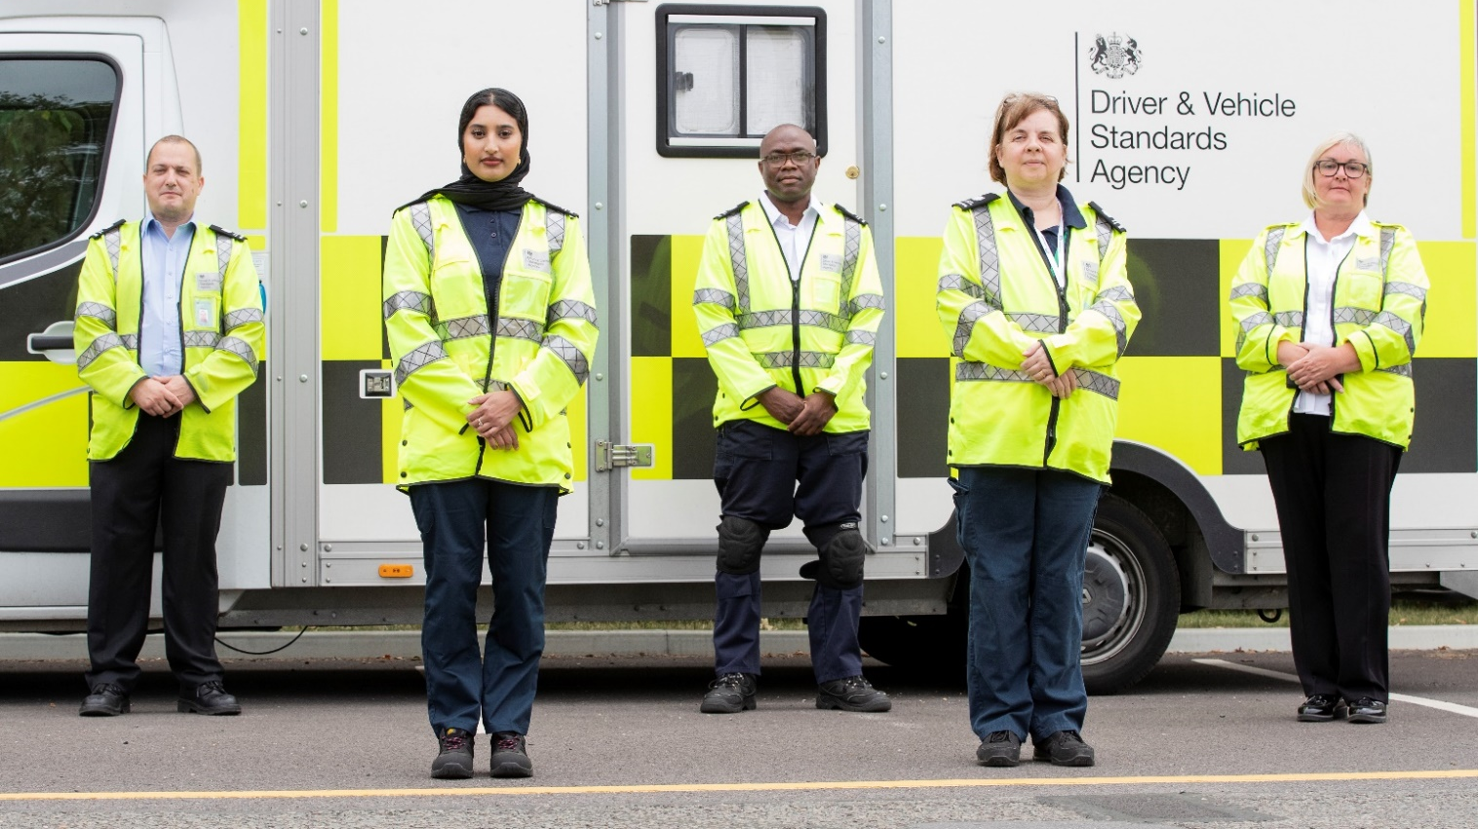

The application
process

The application process: what to expect
There are several stages to the application and assessment process.

Application
You need to submit your application via the Civil Service Jobs website - www.civilservicejobs.service.gov.uk
You’ll need to complete an online judgement test , and provide a behaviour example.
- Example of Civil Service Judgement Test
- Civil Service Judgement Test Video

We’ll assess your application using your behaviour example (Making Effective Decisions) alongside the criteria in the job description and person specification in the previous section of this pack.

Shortlisting
Failure to complete the online judgement test and submit your behaviour example will result in automatic rejection of your application.

Interview and assessment
If you pass shortlisting stage, you will be invited to undertake an online interview.
Pre-recorded video interviewing has been chosen for this stage of the selection process.
You will have the opportunity to respond to questions that have been selected for this role - the best part - you can take this interview anywhere and at a time that is convenient for you within the deadline.
The interview offers you the following benefits:
• The chance to bring your skills and attributes alive
• Really demonstrate why you're ideal for the job
• Demonstrate your communication skills in 'real-time'

We encourage you to complete this interview as soon as possible before the deadline so we can help you if you require any technical support.

Driving assessment
Successful interview candidates will be invited to a driving assessment day (undertaken in a manual car, provided by DVSA).
You will be expected to drive on various types of road and in different traffic conditions. This will include a section of independent driving.
You’ll be asked to give a talk-through of your observations, including how you prioritise risks and plan your responses accordingly. Safety and technique will be assessed, while being mindful of eco-safe driving techniques.
You will be assessed against 12 proficiencies:
- Knowledge and effective use of all controls
- Move-off and stop procedure
- Effective use of all mirrors
- Correct and effective use of signals
- Response to traffic signals/signs/road markings
- Road positioning/normal driving/lane discipline
- Negotiating bends
- Negotiating junctions/slip roads
- Separation distance
- Appropriate speed
- Awareness, anticipation and planning skills
- Maneuvering exercise

Full requirements detailing these 12 proficiencies will be sent to all shortlisted candidates who are invited for a driving assessment.

Eco-safe driving will be highlighted but will not form part of the assessment criteria.

Fixed-term contracts
We’ve followed Government guidance throughout the COVID-19 pandemic, leading to the suspension of testing for prolonged periods. As a result, there is currently unprecedented demand for driving tests.
We intend to employ extra driving examiners to help meet this demand over a fixed period of time, which means your contract will be up to 24 months in duration. This is a temporary position, and the type of contract you will be offered will depend on your current contract status.

External candidates
- If you are not currently employed by the Civil Service, you will be issued with a fixed term contract. Towards the end of the fixed term period, we will reassess our business needs and requirements and if appropriate, you may be offered an ongoing contract.

Across Government (OGD)
- If you are already employed by another government department, either on a permanent or fixed term basis, you will require agreement from your manager and department to apply, then be loaned to the DVSA for the duration of the fixed term contract. At the end of your loan, you will return to your home department.

Internal
- If you are already employed by the DVSA on a permanent or fixed term basis, please ensure you have approval from your line manager before applying.
- For lateral moves, you will revert to your previous post at the end of the contract. If this is not possible due to organisational changes/business reasons, you will be treated in accordance with any applicable redeployment processes or loan guidance.
- If this represents a promotion for you, this would be a temporary promotion (TP) and is classed as a non-substantive promotion. At the end of the TP, you will return to your substantive grade and to your previous position. If this is not possible due to organisational changes/business reasons, you will be treated in accordance with any applicable redeployment processes or loan guidance.

Becoming a driving examiner: the training schedule
DVSA has training locations across the country.
The training course will last a minimum of 5 weeks. You will need to study and pass various pre-course learning packages, and you will be expected to meet a set criterion for each week of the course. For the duration of the training course, you will need to attend on a full-time basis. Our current Training locations are Avonmouth, Beverly, Birmingham, Bishops Briggs, Brentwood, Chadderton, Garretts Green, Gosforth, Llantrisant, Leeds, Norwich, Portsmouth, and Slough.
Although we will make every effort to locate you at your nearest training location, there may be occasions when you are asked to travel to other locations, with DVSA covering the costs.
Week 1 virtual training
You’ll get chance to meet your line manager and colleagues and complete the induction process. We’ll welcome you into DVSA, and introduce you to the driving examiner role, from meet and greets with candidates through to concluding a test and the correct terminology to use.
Weeks 2, 3, and 4, at a regional training centre.
You’ll focus on driving ability and familiarise yourself with the skills required to conduct driving tests. A very high standard of advanced driving ability is required to be successful.
You’ll be introduced to the basics of driving test control, and you’ll get lots of opportunities to practice with your DVSA specialist trainer. As your skill improves, we’ll start to introduce you to methods you’ll use to correctly assess a driving test.
You will develop and consolidate your skills as you progress through these weeks, allowing you to demonstrate through practice sessions and ongoing development that you have the ability to consistently conduct a basic driving test.

We are committed to providing you with a safe working environment.
Standard operating procedures are in place to keep you protected at all times while you’re at work, and regular risk assessments are completed to ensure you are safe.
Procedures include safety and cleanliness standards for vehicles that candidates wish to use for their driving test.
Your safety is always our top priority.

Frequently asked questions

Is this a permanent position?
No. This is a fixed term contract to help meet current demand for driving tests. It will be for a set period, up to 24 months.
Towards the end of the contract timeframe, we will reassess business needs and requirements, and potentially convert some of these roles into permanent positions to meet ongoing demand for driving tests.

Will I be able to change my cluster location?
You will be unable to put in a transfer to another cluster for the first 3 years of your contract.
Please consider this carefully when indicating your preferred cluster location during the application process.
Will I be expected to travel?
Yes. You’ll be sent to local driving test centres within a reasonable commuting distance from your home.
You will be given sufficient notice of any travel away from your ‘base’ testing centre and will be able to claim expenses in line with our Travel and Expenses policy.
How long will the training last?
Training lasts for a minimum of 5 weeks and includes study as well as practical work.
You will be expected to meet a set standard each week of the training course to progress.
What does the training involve?
Please see the training section of this pack for information.
What happens if I fail my training?
If you do not successfully pass training, your contract will be ended and you will no longer be employed by DVSA.

Can I continue to work as an ADI in the evenings and weekends when I am not testing?
No. This is a conflict of interest. If we discover driving test examiners are also acting as ADIs, this is a breach of contract and your employment will be terminated.
You can return to being an ADI when your contract with DVSA has expired.
Will I be required to undergo pre-employment checks?
External candidates will need to undergo pre-employment checks, including a baseline security check. These checks can take up to 20 working days on average.
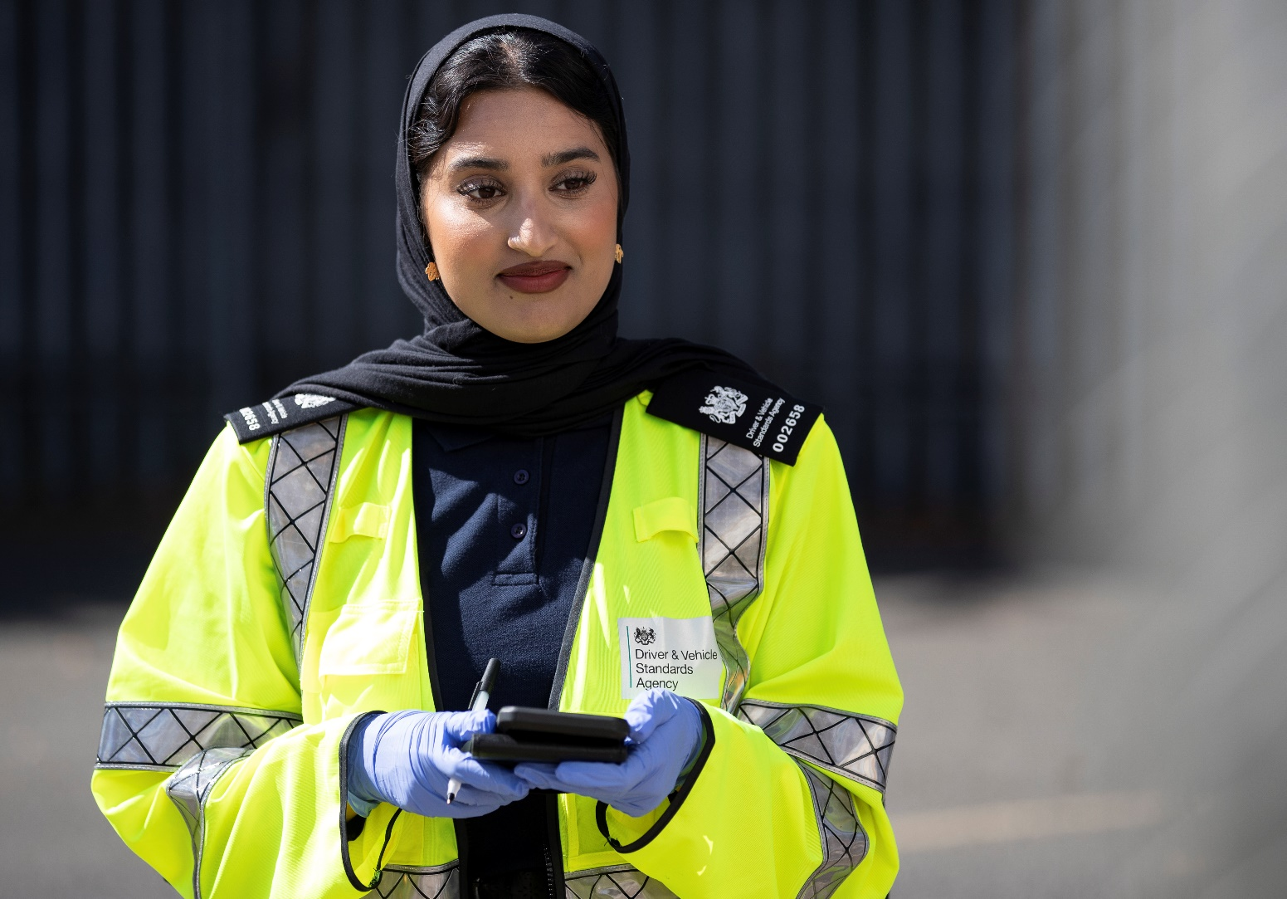

Can I apply if I am not currently a Civil Servant?
Yes, this role is open to all candidates who meet the suitability requirements.

Can I apply if I am currently a Civil Servant?
Yes, please see OGD loan information in Fixed Term Contracts section.

Example of alternate Flexible Working
Full time
We are offering a variety of work patterns available- rotational weekend working. A working environment that supports a range of flexible working options to enhance your work life balance. Our full-time examiners test 5 out of 7 days working a 37-hour week. You will have the opportunity to choose your preferred working pattern from the options listed below.
Option | One Weekend Working in 4 - Rolling Basis
A |  | Mon | Tues | Weds | Thurs | Fri | Sat | Sun
 | wk 1 | Work | Work | Work | Work | Work | Non Working | Non Working
 | wk 2 | Work | Work | Non Working | Non Working | Work | Work | Work
 | wk 3 | Work | Work | Work | Work | Work | Non Working | Non Working
 | wk 4 | Work | Work | Work | Work | Work | Non Working | Non Working
Option | Two weekends in 4 - Rolling basis
B |  | Mon | Tues | Weds | Thurs | Fri | Sat | Sun
 | wk 1 | Work | Work | Work | Work | Work | Non Working | Non Working
 | wk 2 | Work | Work | Non Working | Work | Work | Work | Non Working
 | wk 3 | Work | Work | Work | Work | Work | Non Working | Non Working
 | wk 4 | Work | Work | Work | Non working | Work | Work | Non Working
Option | Two Weekends Working in 4 - Rolling Basis
C |  | Mon | Tues | Weds | Thurs | Fri | Sat | Sun
 | wk 1 | Work | Work | Non Working | Non Working | Work | Work | Work
 | wk 2 | Work | Work | Work | Work | Work | Non Working | Non Working
 | wk 3 | Work | Work | Non Working | Non Working | Work | Work | Work
 | wk 4 | Work | Work | Work | Work | Work | Non Working | Non Working
Option | 3 Weekends working in 4 (2 part weekends , one full weekend ) - Rolling basis
D |  | Mon | Tues | Weds | Thurs | Fri | Sat | Sun
 | Week 1 | Work | Work | Non Working | Work | Work | Non Working | Work
 | Week 2 | Work | Non Working | Work | Non Working | Work | Work | Work
 | Week 3 | Work | Work | Non Working | Work | Work | Work | Non Working
 | Week 4 | Work | Work | Work | Work | Work | Non Working | Non Working

Part Time
We are open to exploring alternative flexible and part time working. This will be discussed with you at the time of offer. Please note the training course can only be completed on a full time basis.

Find out more about working with us
If you want to learn more about what we do, our culture, and what it's like working with us, please see below.
To apply for this role, and to see other vacancies at DVSA, visit Civil Service Jobs: www.civilservicejobs.service.gov.uk
To find out more information about our virtual events and open days, please visit our Driving Examiner microsite:
Driving Examiner Information
Get more information about DVSA, our work and services, at GOV.UK: www.gov.uk/dvsa
Read Despatch, our blog for driver and rider trainers: https://despatch.blog.gov.uk/
Sign up for DVSA Directs on driver and rider training and updates to the Highway Code: www.gov.uk/guidance/dvsa-email-alert
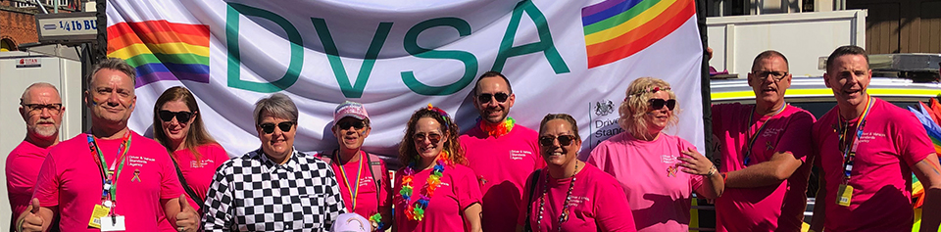

You can also follow us on social media:
Twitter – @dvsagovuk
Facebook – DVSAgovuk
LinkedIn – Driver and Vehicle Standards Agency

DVSA
4th Floor, The Axis Building
112 Upper Parliament Street
Nottingham, NG1 6LP
www.gov.uk/dvsa

If you have questions about the role, or have problems with the online portal or application process, please contact recruitment.newcastle@dvsa.gov.uk

